**PERSONAL PROFILE**

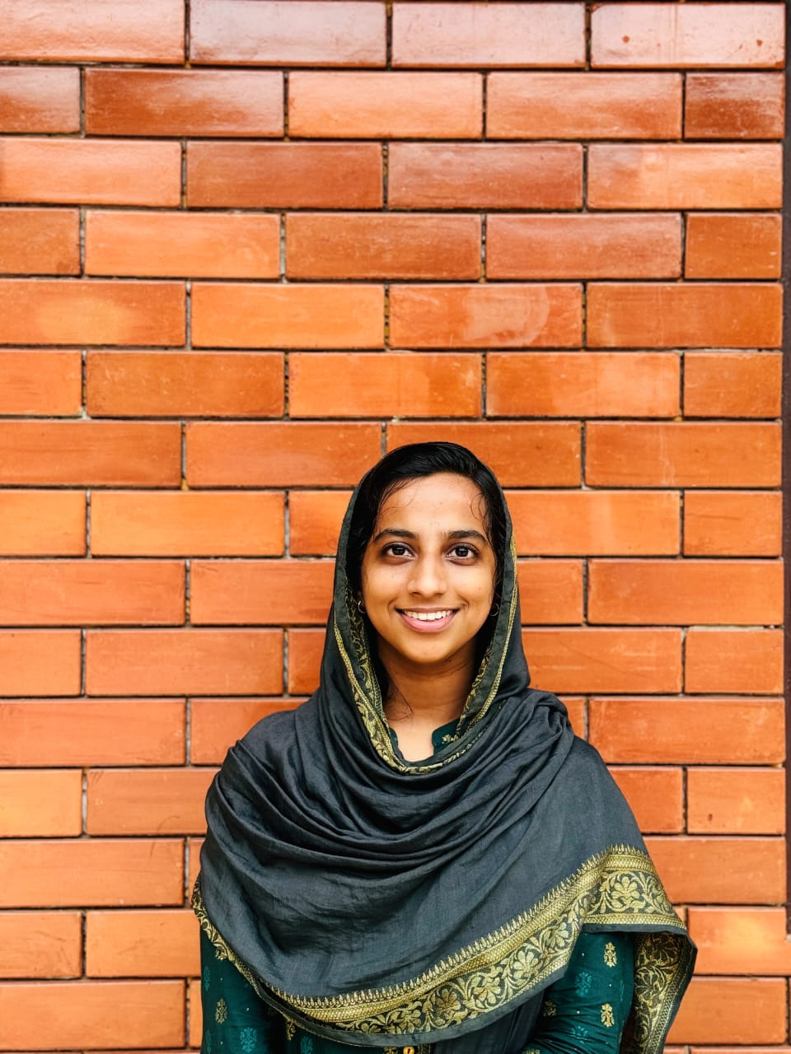

**Fathima P.P Fathima Manzil**

**Assistant Professor Mattool North**

**Department of Mathematics St No: 14, Pin: 670325**

**Sir Syed College Kannur, Kerala, India**

**Taliparamba**

Name : **FATHIMA P.P**

**M.Sc.**

Age & Date of Birth : 23& 15/12/2000

Gender : Female

Marital Status : Unmarried

Nationality : Indian

Religion : Islam

Phone No : 7994828186

E-mail : fathimamtl87@gmail.com

Languages Known : Malayalam, English

**Education**

|  |  |  |  |
| --- | --- | --- | --- |
| **Course** | **Institution** | **Year** | **Specialization** |
| M.Sc. | Department of Mathematical Sciences, Kannur University. | 2021-2023 | Mathematics |
| B.Sc. | Sir Syed College, Kannur University | 2018-2021 | Mathematics |
|  |  |  |  |

**Experience**

|  |  |  |  |
| --- | --- | --- | --- |
| **Institution** | **Designation** | **From** | **To** |
| Department of Mathematical Sciences, Kannur University. | Teaching Assistant | 01.01.2024 | 31.03.2024 |
| Sir Syed College, Taliparamba | Assistant Professor (Ad-hoc) | 10072024 | Till date |

Seminar/ Workshop/ FDP/ Orientation/Refresher Courses Attended: 04

I hereby declare that above mentioned information are true to the best of my knowledge and belief.

Taliparamba

2024 **FATHIMA P.P**